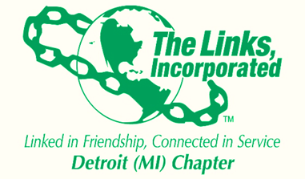

DETROIT CHAPTER OF THE LINKS INC.
Agenda for March 13, 2019
Rattlesnake Club, Detroit

- Let’s Mingle- Links Social (5:30- 6:00 pm)

II. Link-to-Link Activity (6:00 pm-6:30pm)

III. Call to order – Links Hymn and Pledge- (6:15 pm)

IV. Buffet Open (6:30 pm)

V. Roll Call- Link Mearon (6:35 - 6:40 pm)

VI. Call for Acceptance of Consent Agenda- Link Denise (6:40-6:45 pm)

VII. President’s Report (Highlights)- Link Denise (6:45– 6:55 pm)

VIII. 1st Vice Presidents Report- Link Denise (6:55– 7:00 pm)

IX. Treasurers Report- Link Carol (7:10- 7:20 pm)

X. Financial Secretary Report- Link Iris (7:20-7:25 pm)

XI. Program Report- Link Joanna and Link Lesley (7:25- 7:35 pm)

XII. Bylaws Update -Link Denise Lewis (7:35- 7:40 pm)

XIII. New Business (7:40-7:50 pm)

XVI. Amenities- Link Patricia (7:50-7:55 pm)

XV. Adjourn- Link Denise (7:55-8:00 pm)

