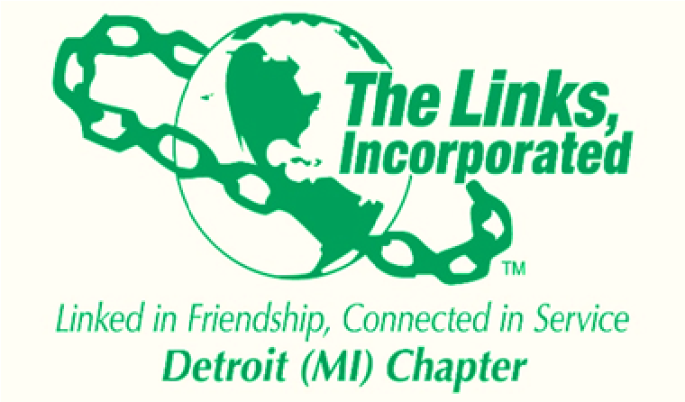

DETROIT CHAPTER OF THE LINKS INC.
Agenda October 11, 2023

- Let’s Mingle- Links Arrive & Socialize (6:00 pm)
- Membership Moments Activity (6:15 pm)
- Welcome & Call to Order– Link Patricia White (6:30 pm)
- Chapter Hymn and Pledge (6:35 pm)
- Roll Call- Link Yolanda Bates (6:40 pm)
- President Report (Highlights)- Link Patricia White (6:45 pm)
  - Minutes Approval
- Treasurer Report – Link Tyra Evans (6:50 pm)
- Programming Report – Link Kristi Stepp (6:55 pm)
- Vice President Report- Link Kim Keaton- Williams (7:00 pm)
  - Candidate Presentations
- Old Business
  - Winter Trip Follow-up

- New Business - Acknowledgements

- Adjourn Link Patricia (7:45 pm)

