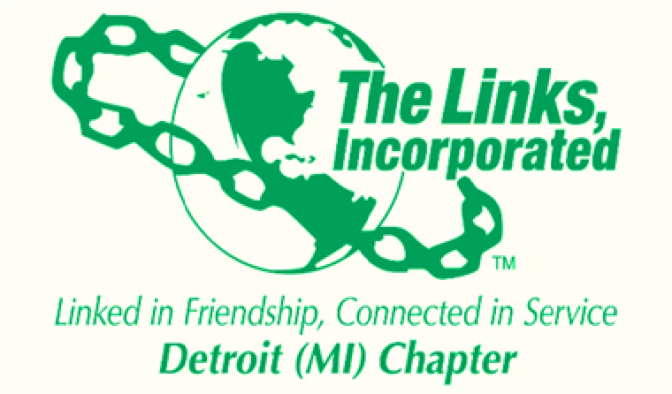
DETROIT CHAPTER OF THE LINKS INC.

Consent Agenda for October 9, 2024
- Let’s Mingle- Links Arrive & Socialize (5:45 p.m.)
- Membership Moments Activity (6:00 pm)
- Welcome & Call to Order– Link Kim (6:25 pm)
- Chapter Pledge and Hymn (6:30 p.m.)
- Roll Call - Link Khalilah (6:35 p.m.)
- Call for September Minutes Approval - Link Kim (6:40 p.m.)
- Call for Approval of October Meeting Consent Agenda – Link Kim (6:43 p.m.)
- President’s Report (Highlights)- Link Kim (6:45 p.m.)
- Vice President Report- Link Kristi (6:55 p.m.)
- Financial Updates – Links Tyra, Yolanda, and Angel (7:00 p.m.)
- Programming Update – Link Roshunda (7:10 p.m.)
- Fundraiser Update – Link Marcia (7:15 p.m.)
- Bylaws Update – Link Gladys (7:20 p.m.)
- STEAMM Update – Link Katrina (7:25 p.m.)
- Protocol Moment – Link Jenice (7:30 p.m.)
- Ethics and Standards Training – Link Shirley (7:35 p.m.)
- Hat Strut – Links Christina & Marlo (7:40 p.m.)
- Technology Moment - Link Katrina (7:50 p.m.)
- New Business (7:55 p.m.)
- Amenities (8:00 p.m.)
- Adjourn Link Kim (8:05 p.m.)


Meeting Minutes September 11, 2024
*Due to an l issue with the audio recording, we are unable to provide detailed minutes.
Link Khalilah has asked Technology Chair Link Katrina to assist and troubleshoot so it is not an issue in the future.

Call to Order: President Kimberly Keaton called the meeting to order.
Attendance / Roll Call: Taken by Link Mearon Lewers. A quorum was established. All active members were present except: Khalilah Spencer, Gladys Ayala Prempeh, Deborah Ford, Kimberly Gill, Tiffany Gunter, Marcia Holland Turner, Denise Lewis, Allison Martin, Joanna Masten, Michele Peterson, Lauren Sanders, Alison Vaughn, Jeanne Wardford, Markisha Williams, Cassandra Willis-Adner, Chrystal Wilson.

Hymn followed by Pledge

Approval of Minutes: Moved and seconded and approved by the body.

Approval of Consent Agenda: Moved and seconded and approved by the body.

President’s Report: Link Kimberly Keaton – Written Report provided with Consent Agenda
Vice-President’s Report - Link Kristi Stepp Verbal report provided at meeting
Treasurer’s Report - Link Tyra Evans - Written Report provided with Consent Agenda
Fundraising Committee - Link Denise Brooks-Williams – Verbal report provided at meeting.
Program Chair Report: Roshunda Price - Written Report provided with Consent Agenda
Technology Training: Link Katrina Marion
Protocol Moment: Link Judy Neely

New Business: No new business
Old Business: No old business
Meeting Adjourned: The meeting was adjourned.

October 2024 President’s Report
The Detroit (MI) Chapter of the Links, Incorporated

Priorities
- Friendship: The foundation of our organization, enabling everything that we do.
- Member Engagement: This is your chapter. Your voice matters. Bring your ideas and talents.
- Service: Let us serve our community and our chapter, to the best of our ability.
- Operational Excellence: Effective and efficient processes that enable our chapter to run well and be compliant with national requirements.
- 45th Links National Assembly: Plan and prepare. Detroit. June 24-28, 2026.
Rhythm and Rhinestones
- Congratulations to US for hosting a fabulous, fun, and successful fundraiser on September 28th at the Detroit Historical Museum!
- Thank You to our Fundraiser Committee! Chairs: Link Denise Brooks-Williams, Allison Martin and Marcia Turner. Committee Members: Yolanda Bates, Sandra Bulger, Tamira Chapman, Shauna Ryder Diggs, Lesley Fairrow, Kimberly Gill, Gail Perry-Mason, and Michele Peterson.

Walk for A Healthy Living
- The Metro Detroit Chapters collaborated (for the second year) for our health walk at Normandy Oaks Park in Royal Oak on September 28th. We also promoted voter education and registration.
- Thank You to our HHS Facet for promoting the event and beautiful gift baskets for raffle winners.

Central Area Summit. Omaha, Nebraska (October 31 – November 3, 2024)
- Mastering the Playbook: Strategies for Excellent Leadership
- 4 Tracks: 2 Leadership (1 for Presidents/VPs, 1 for other elected officers, facet chairs, committee chairs and aspiring leaders), 1 Fund Development, 1 Programming).
Bylaws Updates
- Phase 1: The Detroit Chapter Bylaws will be updated to comply with the new bylaw amendments that were voted on at the 44th National Assembly.
  - Updates due to the Area Parliamentarian by November 1st.
  - Area Parliamentarian will submit amended chapter bylaws to the National Parliamentarian by November 30th.
- Phase 2: The Bylaws committee will lay out a timeline for chapter members to submit recommendations for additional changes to our bylaws.
Social Action
- Link Up The Vote – National goal for the Links to register 100,000 new voters (335 per chapter).
- In support of LUTV, please come out to support our NTS Facet Activity on October 10th at Marygrove.
- Link Alexis Wiley (GWCC) established a partnership with the state of Michigan to create a unique Links, Incorporated (Metro Detroit Chapters) link to register voters and track our progress.

Meal Payment Plan
- Thank you Link Sisters for helping us successfully launch our streamlined meal payment plan.
- 35 Link Sisters enrolled in the meal plan.
Preparation for the 45th National Assembly
- Madam National President Ethel Isaacs Williams, Madam Executive Director Joi Sheffield, and Madam Protocol Chair Vonda Rice visited Detroit October 3rd-4th to plan for the 45th National Assembly, 2026.
- National leaders met with the Metro Detroit Presidents for dinner on October 4th to give a high- level overview of the 2026 National Assembly.
- Madam President Ethel and Madam Protocol Chair Vonda also visited the Detroit Historical Museum to see “Our History, Our Story”. Thank you Link Michele for serving as the tour guide. MP Ethel was so impressed that she requested a video of the exhibit and she plans to share the video at the 2026 National Assembly.
- From a financial perspective, our key 45NA responsibility will be hosting a Tuesday (June 23rd) dinner event for National and Metro Detroit Leaders. An assessment is generally used to support this responsibility.
- We also help find sponsors for the National Assembly (dollars and in-donations).
- Madam President plans to return to Detroit, January 2025, to host a Town Hall for Metro Detroit Links.
Chapter Meeting Venues
- Detroit Golf Club: September 2024, December 2024, March 2025, April 2025.
- Aurora Italiana Restaurant: October 2024, November 2024, February 2024.
Important Upcoming Dates
- October 10th: National Trends and Services Program, Every Vote Counts. Marygrove, Detroit.
- October 17th and November 21st: Mandatory Ethics Training, 9 p.m. (Choose 1 session)
- October 31st – November 3rd: Central Area Summit. Omaha, NE
- November 2nd: STEAMM Youth Event (Metro Detroit Links). 9 a.m. – 3 p.m. UD Mercy, Detroit.

In Friendship and Service,
Link Kim

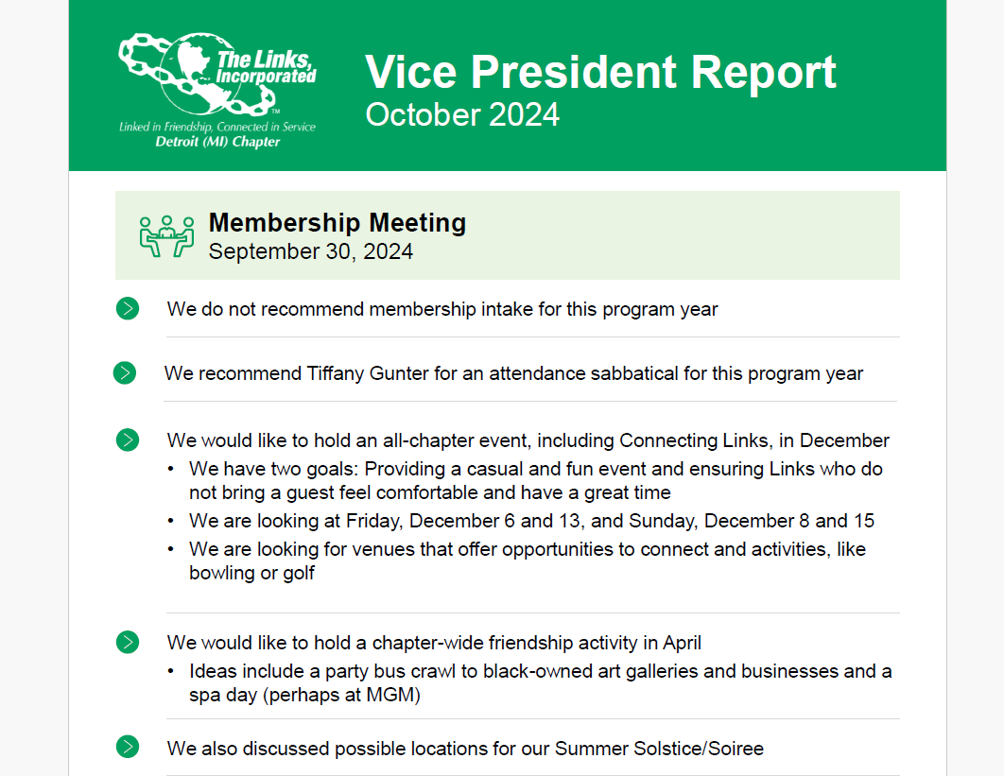
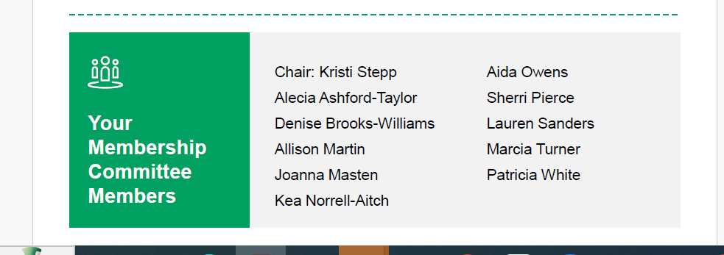
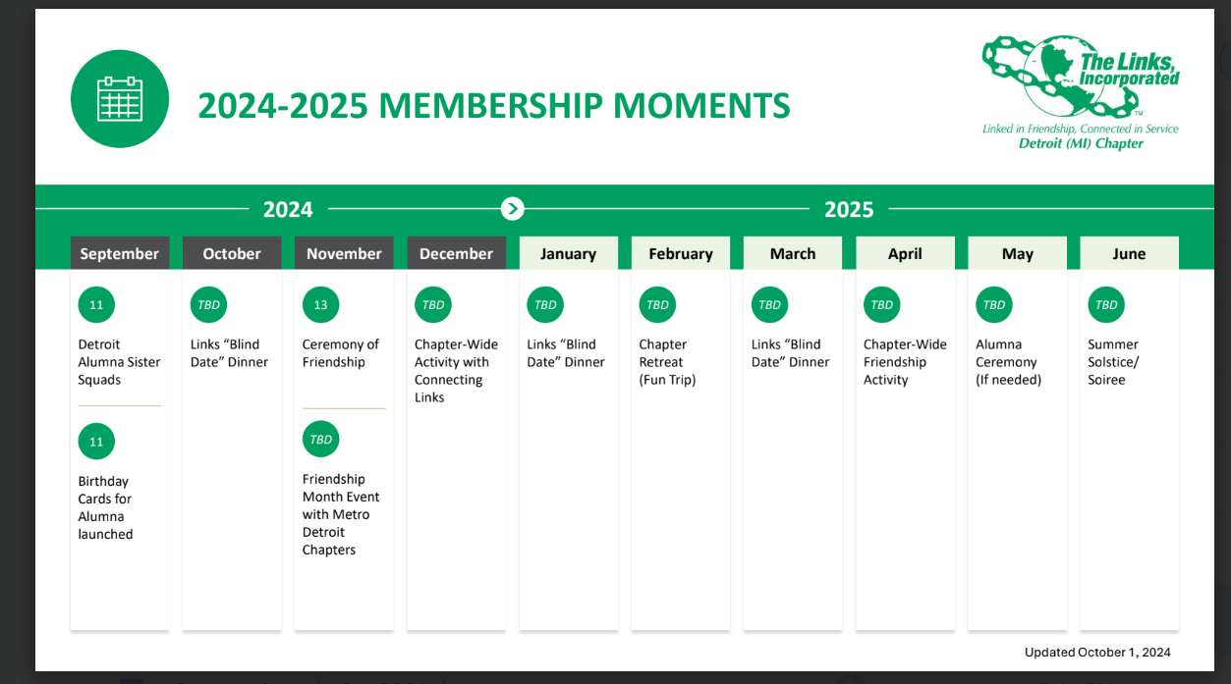

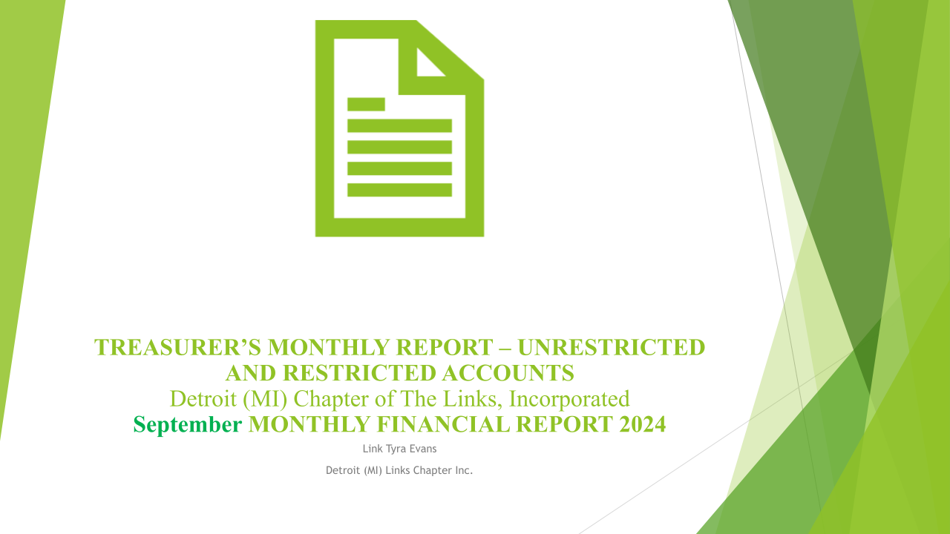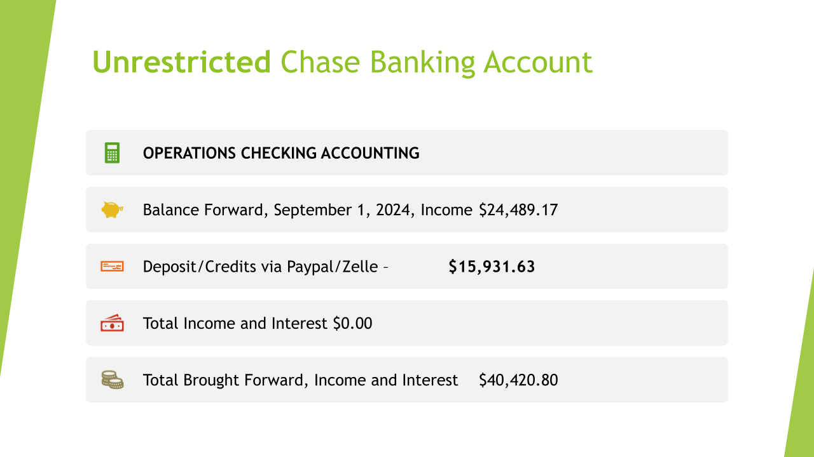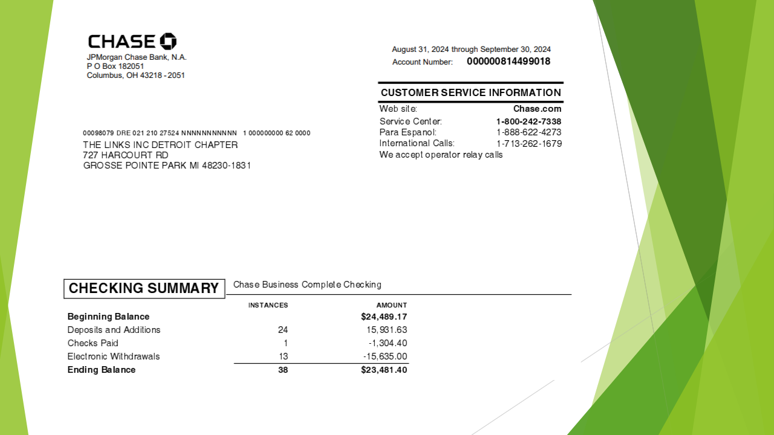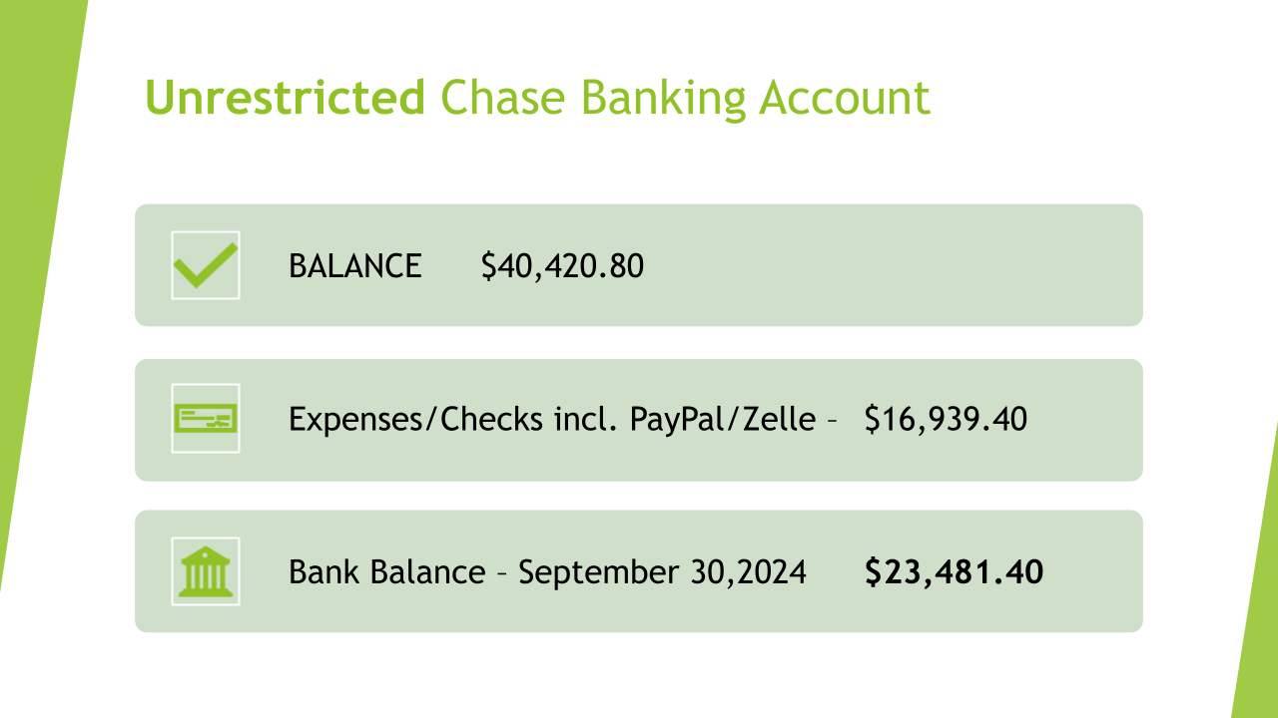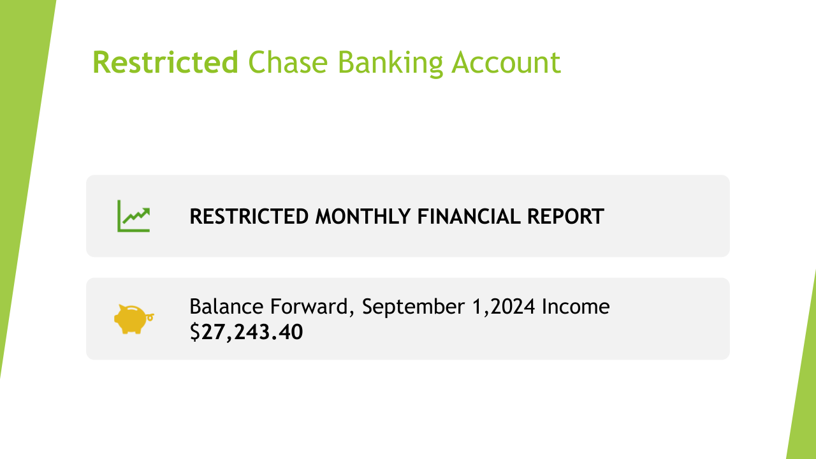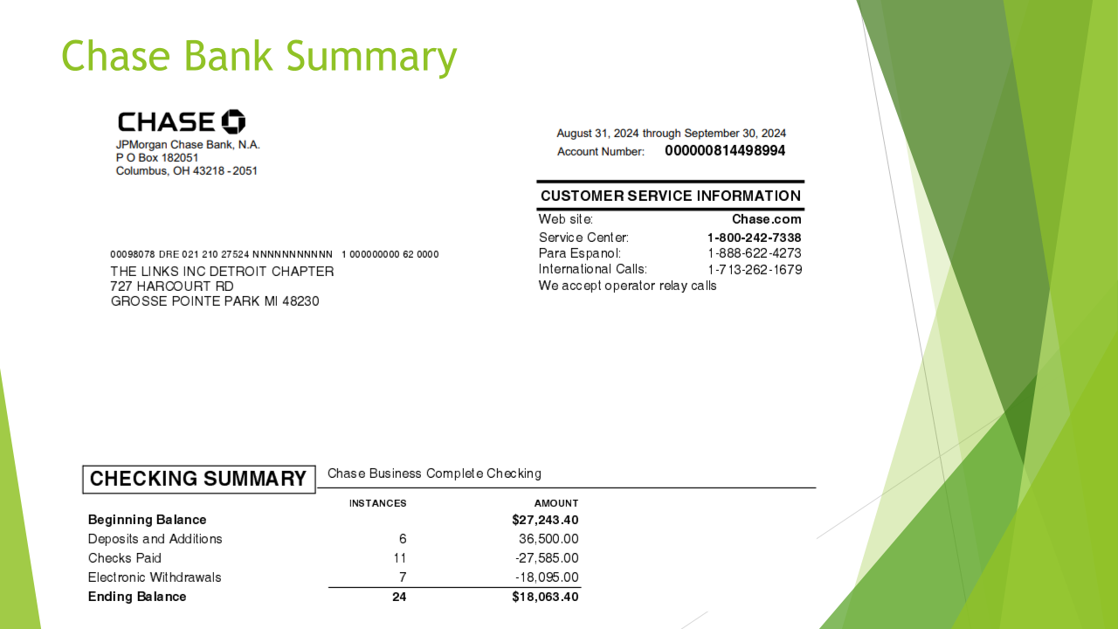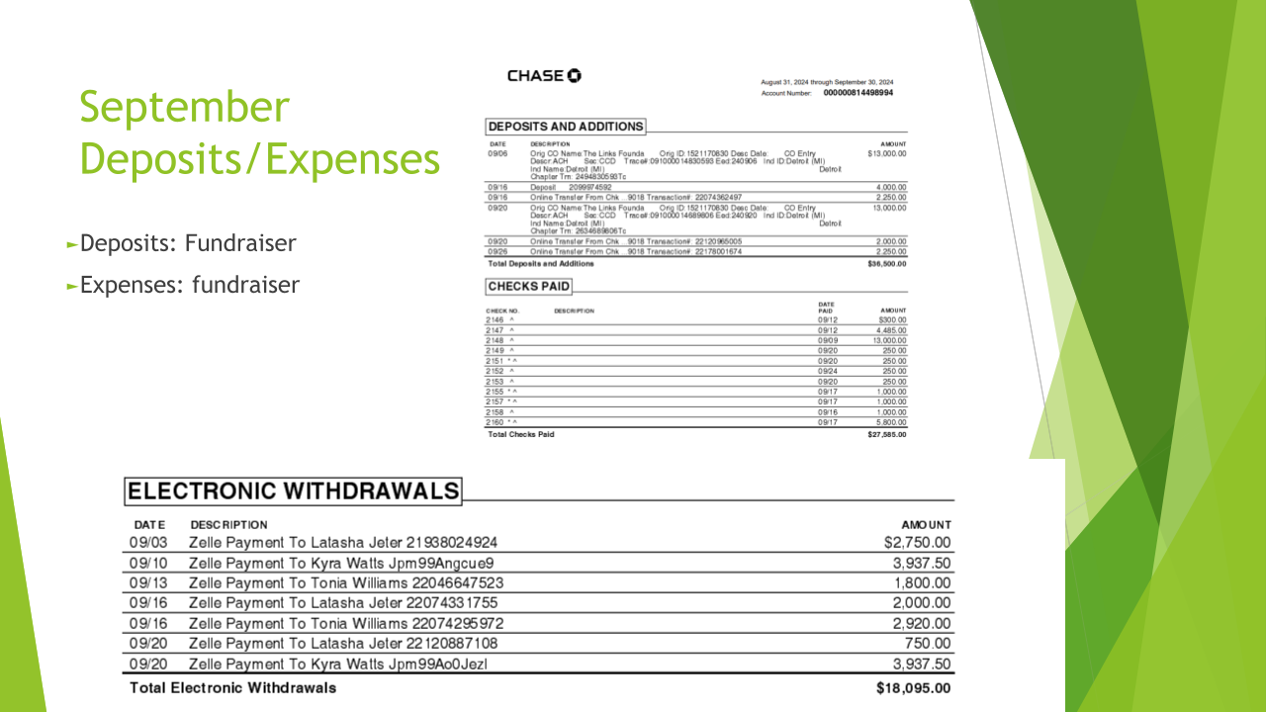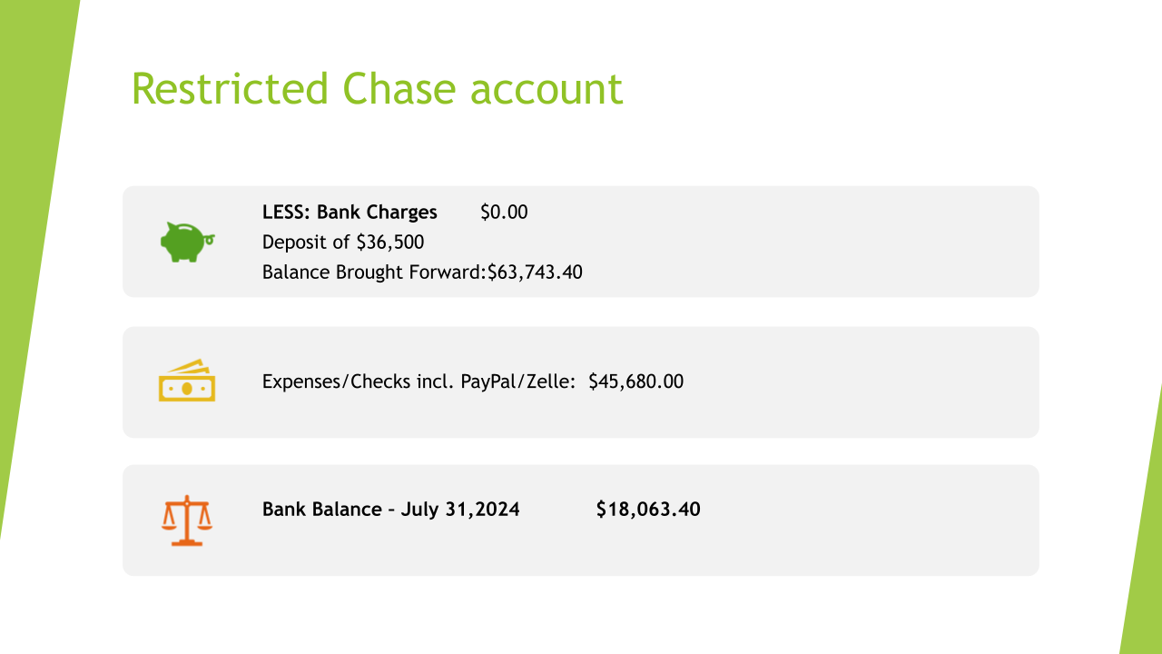

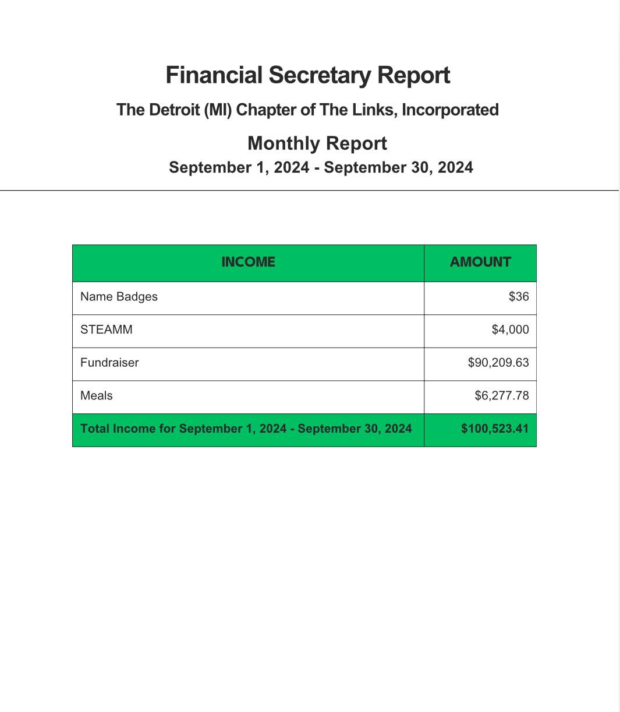
Program Committee Report
October 9, 2024
Roshunda Price, Chair

Program Committee: HHS: Christina Clark* and Marlo Johnson Roebuck**; ITS: Gail Perry-Mason* and Dr. Jeanne Wardford**; STY: Shirley Mobley Woods* and Joanna Masten**, NTS: Sherri Pierce* and Linda Parker**; Arts: Chrystal Wilson* and Kimberly Gill**
*Chair; **Co-chair
Upcoming Activities:
- Chapter Hat Strut: Will take place during the October chapter meeting.

- National Trends and Services Facet Activity/ Link Up The Vote: Thursday, October 10, 9:00 am – 10:40 am, The School at Marygrove.

- Black Family Wellness Expo, March 15, 2025.

- Other chapter and national programming: There are numerous chapter and national program initiatives; we cannot do them all. To have the greatest level of chapter engagement and participation, and program success, the Program Committee will review the list of recommended programs and bring recommendations to the chapter. The will of the chapter will be the final determinant for programming outside of the facet programs.

Service Hours: An additional service hour will be provided for members who volunteer to work with a facet for which the member is not assigned.

Alumna Member Participation and Support: Please consider inviting Alumna members to facet and chapter programming, and, at the discretion of the committee/facet, planning meetings.

Chapter Meeting Report Out: Upcoming facet activities and chapter programs will be announced during chapter meetings to facilitate chapter-wide participation.

All Links are encouraged and expected to participate and support all facet and chapter programming. Per the chapter bylaws active members “Must participate in Chapter activities and programs designed to implement the national programs of the The Links, Incorporated.”
Parliamentarian Report
October 9, 2024 Chapter Meeting
Detroit Chapter of the Links

Bylaws Update

- Detroit Chapter Bylaws were last amended on November 9, 2022. The amendment was made to Article IV – Officers, Section 1, on the recommendation of then Central Area Director Link Monica Allen through the Bylaws Committee. The change made the Operations Chair an appointed member of the executive team. Link Monica has also recommended we amend our bylaws to formally reference the office of Operations Chair, which required an affirmative vote of the membership.
- Reminder that Article XI of the Bylaws addresses the process to propose amendments:
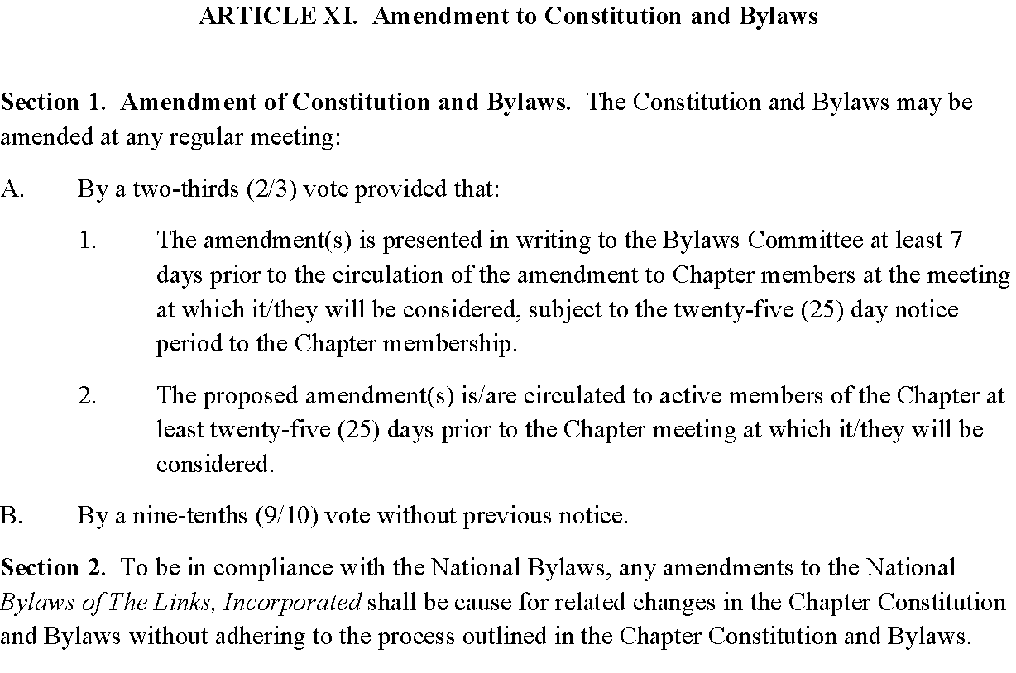
- See also:
ARTICLE VIII. Program/Facets and Standing Committees, Section 3.
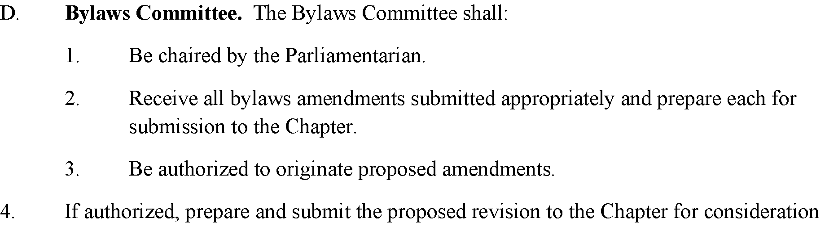
- While the revisions to comply with the National bylaws do not require a vote of the chapter membership, we are asked to review, amend our chapter’s bylaws, and forward a copy to Area Parliamentarian, Link Denise Mustiful-Martin no later than November 1, 2024.
- The Bylaws Committee will meet to ensure our Chapter’s bylaws conform to the National bylaws and are submitted on time. We will discuss accepting amendment proposals according to the Articles cited above.
- No additional updates.

Respectfully submitted by
Chapter Parliamentarian
Link Gladys Ayala Prempeh

